**High-Level Requirements**

For our solution to be considered successful, it must achieve the following three goals:

* The device must be able to turn one page within 5 seconds ± 2 seconds. This motion should be repeatable for turning a page backward.
* The device must be able to turn at least ten consecutive pages, with 95% ± 5% accuracy, and take at most 1 minute ± 10 seconds when the foot pedal is pressed consecutively.
* The device must be able to store the total number of pages turned in a single sitting, with 95% ± 5% accuracy, and display this information to the reader.

**Block Diagram**

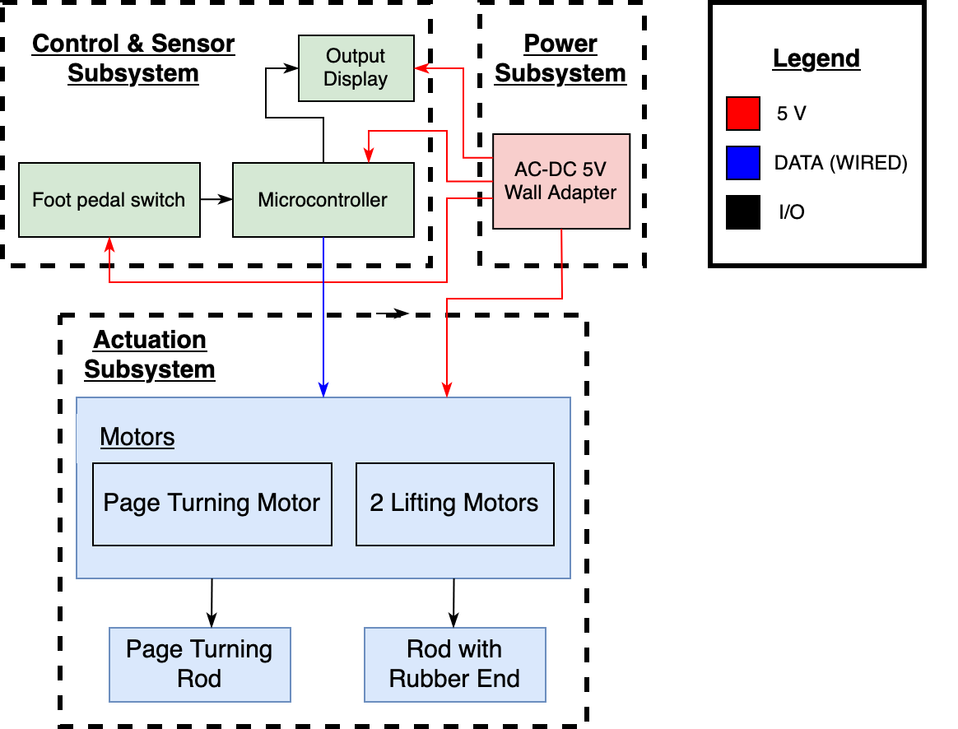

**Subsystem Testing**

**Power Subsystem**

| Requirements | Verification |
| --- | --- |
| * Must have a 5V wall adapter that plugs into a wall outlet. * All components on the PCB must be supplied with 5 V ± 5%, when the device is idle and active. | * Use a multimeter to check that the wall adapter’s barrel jack is supplying a steady 5V ± 5%. * Measure the voltage across each device using an oscilloscope. Repeat this process when a foot pedal is pressed. |

### 

**Actuation Subsystem**

| Requirement | Verification |
| --- | --- |
| * The servo motors must create negligible backwards EMF. * The motors should cause minimal damage or tearing to the pages in the book. | * Use an oscilloscope to plot the voltage of a motor when idle and when active. If the voltage spike is 1V ± 0.5V, we can consider the backwards EMF from the motor to be negligible. * Run 10 test trials to find the best angle and speed for each motor. |

**Control and Sensor Subsystem**

| Requirements | Verification |
| --- | --- |
| * When the left foot pedal is pressed, the motors should turn a page backward. When the right foot pedal is pressed, the motors should turn a page forward. * The LCD should track the number of pages turned forward. | * Ensure that the left motor rotates 45°-135°-45° and the center motor rotates 0°-90°-180° when the left pedal is pressed. Ensure that the right motor rotates 135°-45°-135° and the center motor rotates 180°-90°-0° when the right pedal is pressed. * When the right foot pedal is pressed, the count should increase by 1. If the left foot pedal is pressed, the count should decrease by 1. |

**Software Flowchart**

